ITA0305- Mobile Computing
LAB EXPERIMENT
Name: G.Ganesh
Reg NO:192373008

22) Analyze latency trends in a simulated mobile network.

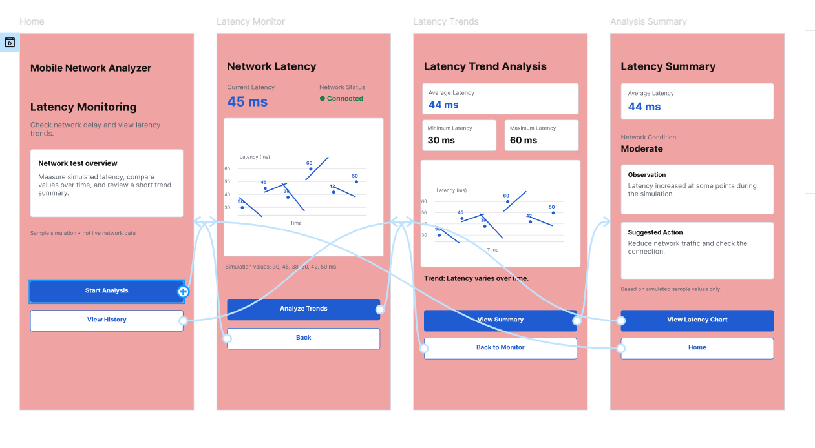
https://www.figma.com/design/BDYb2z7gycFjMofUXXcAep/program22?node-id=0-1&p=f&t=56uSg3BEoJFWFiDc-0

